**A Flexible And Investigation Approach For Encrypted Features Space Using Neural Network**

| 1**Sheetal Prasad**  (sp2722@srmist.edu.in)  #*STUDENT*  *Department#of#Computer*  *Science#and#Engineering*  *SRM#Institute#of#Science*  *and#Technology* | 2**Piyush Raj Shrivastava**  (ps5254@srmist.edu.in)  *#STUDENT*  *Department#of#Computer*  *Science#and#Engineering*  *SRM#Institute#of#Science*  *and#Technology* | 3**Mrs. Archana T** (archanat@srmist.edu.in)  *ASSISTANT#PROFESSOR*  *Department#of#Computer*  *Science#and#Engineering*  *SRM#Institute#of#Science*  *and#Technology* |
| --- | --- | --- |

***Abstract***

**In this article, we present an approach control mechanism for article observation replicas .The usage of encrypted pictures or encoded attribute plots has been shown to be successful in preventing unwanted approach to models.The approach's efficiency has only been verified in image organization models and semantic analysis models, not in article recognition models. For the first time, encoded feature plots are proved to be successful in approach control of article observation replicas in this study.**

**We present a safe and efficient technique based on completely homomorphic encryption and demonstrate its usefulness for a variety of real data.The suggested technique is the first to directly replicate an algorithm on ciphertext, which is one of the best performers on the plaintext feature selection problem. Furthermore, the suggested protocol is simply extensible to the scenario of more than three data owners.**

***Keywords—Encryption, Neural Networks, CNN***

1. INTRODUCTION

The spread of various cell phones with cameras leads to a rapid increase in the number of photos. Current improvements in deep teaching with convolutional neural networks (CNN) have made CNN characteristic withdrawal a viable method for processing these photos.

However, deploying the CNN model on cellphone devices, which are often the limitations of inputs available to complete a particular job in terms of the storehouse, computational capability, and a measure of battery performance and longevity, remains a difficult issue. Despite the fact that cloud computing has become an admired option, data security and reaction halt remain critical challenges. It is difficult to fulfill the three requirements of privacy, accuracy, and efficiency when creating a privacy-preserving CNN characteristic production strategy for cellphone sensing. The privacy-preserving CNN feature extraction might take place at the network's edge. This is done by generating a random transmission above connecting the end devices and the perimeter servers. Through conceptual examination and factual investigation, demonstration of the dependability, success, and regulation of the strategy is done.

1. LITERATURE SURVEY

Shaojing Fu, Ximeng Liu, Kai Huang, Deke Guo, and Ming Xu,[1] introduced in 2019, the stretch of diverse mobile appliances rigged with cameras leads to an exponential proliferation in several photographs. Contemporary improvements in in-depth learning along with convolutional neural networks (CNN) drove CNN feature extraction into a viable method for processing these photos. However, deploying the CNN sample on mobile detectors, which are often resource-curbed in stints of storage space, computational capability, and battery life, remains a difficult hardship. Although cloud computing remains a prevalent choice, data security and retort latency remain critical challenges.

For streamlined and decoupled services[2], relatively simple and computationally inexpensive methods, and to significantly reduce computational complexity, Yan Luo, Hao Yin, Zexun Jiang, and Jiaying Gong proposed an A.M.A.C.S. framework in their paper in the addendum to the across-the-board configuration, they held considering the interpretation of the A.M.AC.S. AMC proposes two current methods for investigating the efficiency of mobile apps. According to the results of the evaluation, A.M.A.C.S. can be used in applications such as social sensing. Its drawbacks were that it was difficult to deploy to large-scale parallel computing, was not properly investigated, and could not be implemented in real-time.

Jingmin Tu, Li Li, Jian Yao, Binbin Xiang, and Wenjie Zhao in a 2021[3] paper extract rod-shaped entities taken from mobile LiDAR promontory cloud data to enable a more powerful system that further reduces the numeral of manpower mandated. Introducing a new approach to Efforts has made it easier to distinguish the impact, improving efficiency and speed. The proposed method relied solely on the X, Y, and Z coordinates without any further facts or training data, and the parameters stood fixed to the edifice of the various rod-shaped objects. It also has some drawbacks, such as hardships with large-scale parallel computing, complex tasks, and complexity and inefficiencies.

# Weichao Wang, Hanshang Li, Ting Li, and Yu Wang published 2019 to improve operational efficiency, eliminate the heavy workload of traditional methods, and improve the effectiveness of distributed optimization [4]. Both online and offline code structures are delivered to embark on difficult challenges. Ample simulations on authentic mobile datasets have exhibited the effectiveness of the presented method. It couldn't be delivered in real-time, had an extensive payload, and required time-consuming notice updates. All of this puts the model at peril.

J Furukawa, Y Lindel A, T Araki In a 2016 paper [5], Nof and K. Ohara described accelerated secrets and simple operations beyond the protocol based on accelerated secrets and simple operations using CI's XOR and AND gates. We have made great efforts to generate a protocol based on. Use XOR and AND data.

Ali Sharif Razavian, Stefan Carlsson, Josephine Sullivan, and Hossein Azizpourcollaborated in 2014 [6] with the renowned prospect for saleable and cataloging applications, with common expressions subtle using deep learning and CNN. It was a good test to see if they could capture the details, but they could merely extract one attribute from the bounding parcel roughly close to the person.

A 2016 paper by Li Fei Fei, Andrew Karpathy, and Justin Johnson[7] enabled end-to-end training for efficient time-testing performance. I used a fully collapsed localization network. The only problem was that there were some differences between regional and image level statistics.

Qingquan Li, Yatao Zhang, Wei Tu, Ke Mai, and Jinzhou Cao, in a 2021 article [8], linked the fusion of secluded sensing photographs and human perceptual data to the spatial hierarchy for more sumptuous flexibility and affiliated dominion. Has been improved in more detail. More compact information, optimized and isolated services. The only downside was that it couldn't keep up with the modern networking business.

In 2018`s journal of computer vision[9], Andrea Vedaldi and Karel Lenc employed deep convolutional networks, which substantially decreased the number of parameters to prepare and could be executed economically as a supplementary coating of the CNN. Its main shortcoming was that it only predicted a narrow array of 5x 5 HOG cells.

According to Dr. Anna Saro Vijendran and S.Thavamani [10], a peer-to-peer (P2P) grid enables decentralized, self-systematized, scalable entities in circulated computing techniques. Such networks, nonetheless, are dismayed by absurd latency, network gridlock, and cache update tribulations. There is no perfect solution to these challenges in the present caching and miniature sequence strategies for putting items over peer-to-peer grids. This study addresses a new, popular-based grade of usefulness enabled clever counterpart deployments for range delivery over peer-to-peer overlay grids to manage entrance pause, disparage tolerance, network traffic, and resolved monotony difficulties. Provides a way at a low cost. This study also outlines existing algorithms and their strengths and weaknesses.

The mobile phone has evolved into a system that can capture and send different data types (image, voice, location) as well as voice and text communication. With the acceptance of these more powerful technologies in society, a potentially broader perceptual paradigm of participatory perception has emerged. Collaborative participatory sensor systems use mobile phones to recruit users and study interesting phenomena through on-site data collection. Several technological hurdles must be overcome for participatory sensing to be successful. We focus on one specific topic in this paper: establishing a recruiting framework to help organizers find well-Fit volunteers for data collection established on geographic and secular availability, also in participation routines. This recruiting approach was assessed via a succession of test data collections in which enlistees investigated sustainable procedures on an academy campus. This was explored in Sasank Reddy, Deborah Estrin, and Mani Srivastava's study[11].

In their paper[12] Michał Piórkowski, Natasa SarafijanovicDjukic, and Matthias Grossglauser provide Mobile wireless networks frequently have both dense and sparse connection locations at the same time, for instance, due to a heterogeneous system end-point disbandment or radio propagation circumstances. The goal of this particular research is to represent mobility and group formation in such grids, where nodes are formed in bunches of drastic connectedness knitted with scant association. Uniformly viscous and scant networks have been widely investigated in the past, while bunched networks have fetched less attention. Here a novel mobility model for clustered networks, which is useful for the designing and the evaluation of routing algorithms.

Toshinori Araki, Jun Furukawa, Ariel Nof, Yehuda Lindell, and Kazuma Ohara collaborated on an ACM SIGSAC Conference[13] in which they offered a unique information-theoretic protocol (and a computationally secure interpretation) for protected three-party computing with an unpretentious preponderance in this investigation. The required protocol had overly little processing and transmission; in the Boolean circuits, individual side dispatches only a single bit for every AND gate. In presence of semi-honest adversaries, this protocol is (simulation-established) safe, and in the existence of malevolent rivals, it executes solitariness, most particularly in the client/server architecture.

In their 2014 paper[14] Ali Sharif Razavian, Hossein Azizpour, Josephine Sullivan, and Stefan Carlsson reported upon a sequence of investigations executed for distinct recognition assignments utilizing the publicly known code and model(the OverFeat network) that was prepared to accomplish object sorting upon ILSVRC13. They employed attributes generated from the Over Feat grid as a general picture expression to bear a broad spectrum of recognition undertakings such as entity picture sorting, scene marker, pleasing-grained recognition, quality detection, and picture recovery on a lot of data.

1. #HARDWARE#AND#SOFTWARE #REQUIREMENTS#

**Hardware#Requirements**

* Processor: Minimum i3 Dual Core
* Memory (RAM):#Minimum 8 GB; Recommended 32 GB or above
* Hard Drive: Minimum 100 GB; Recommended 200 GB or more
* Ethernet connection (LAN) OR a wireless adapter (Wi-Fi)

**Software Requirements**

* Python
* Anaconda
* Jupyter Notebook
* TensorFlow

The code implementation of this model was done on a Windows 11(home)(64-bit), intel i7H processor with 16 GB RAM and 1TB storage with the latest Python version 3.10.4.

Datasets used for preprocessing were obtained from Kaggle.

IV. PROPOSED SYSTEM

The addition of various cellphone instruments with cameras leads to an expanding increase in the number of photos. The latest progress in deep learning using convolutional neural networks (CNNs) have made CNN feature modification a viable method for processing these photographs. However, deploying the CNN model to mobile sensors remains a challenge as it is often limited in terms of repositary space, processing power, and storehouse life. Cloud computing has become a favoured option, but data privacy and reaction delays remain important challenges

.

Create a set of secure interconnection instructions, use two perimeter servers for collaboration, and perform CNN characteristic extraction to take full advantage of CNNs with restricted physical resources on cellphone sensors. The proposed approach allows you to significantly minimize end device latency and overhead while maintaining security. Through conceptual inspection and hands-on testing, we illustrate the safety, advantages, and organization of our approach.

When developing a strategy to extract CNN privacy features for mobile collections, it is difficult to meet the three processes of security, accuracy, and efficiency. Previous work relied heavily on strong cryptographic primitives to meet privacy standards. The complexity of CNNs inevitably reduces the accuracy and efficiency of methods. In this article, we built our own lightweight framework that integrates mobile sensing and edge computing. Extraction of CNN functions that protect privacy can be performed at the edge of the network. First, it creates a random transmission overhead among the end device and the perimeter server. Next, test your privacy approach. This is achieved by filtering one occasion with three webs at two edges. Most tiers are very powerful because they can be run locally by the server, and the price of this method is prioritized by the operation tier and the largest pool tier. This study provides an overview of image manipulation with private keys and their applications. By modifying an image with a private key, you can protect the visual information of ordinary photos while embedding characteristic key control elements in the image. In addition, various encryption algorithms can provide encrypted images that are compressible and can be learned through machine learning. Using these qualities, several applications for such conversions have been developed. This research focuses on a type of image modification called learnable image encryption. This helps maintain the privacy of machine learning and resilient defenses against adversaries. There is a detailed description of both the conversion method and its performance.

With learnable encryption, you can apply the encrypted data directly to your model as training and test data. Encrypted photos usually contain less visual information than plain images, so using visually protected images allows you to learn while maintaining privacy. .. You can also use a private key to incorporate unique key-controlled elements into your photos.

Security most of the time is referred to as a safeguard from hostiles. Most image alteration methods are intended to safeguard visual information that allows us to identify a person, a time, and the place of a photograph. Untrustworthy suppliers and illegitimate users are regarded as opponents.

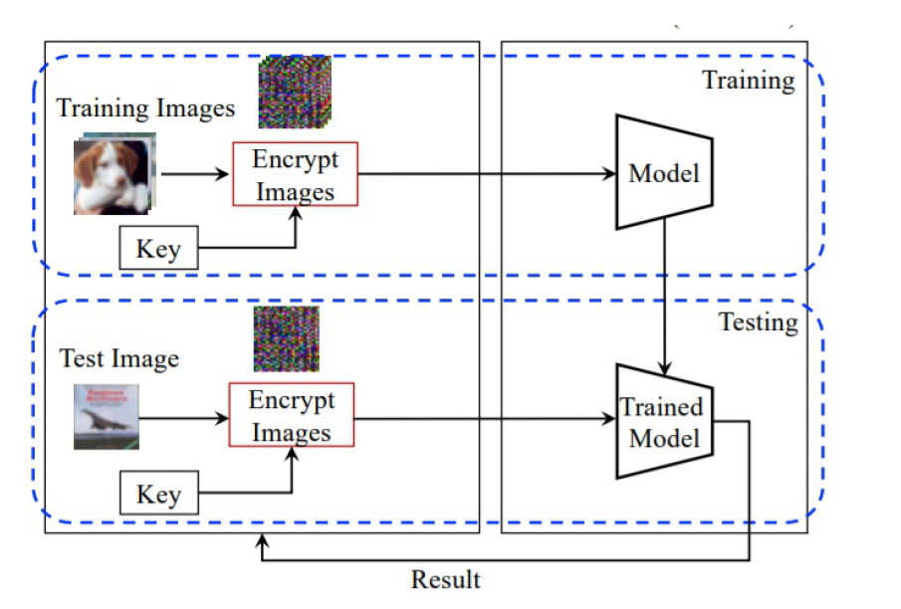

*Fig.1. Architecture Diagram of the proposed system*

There are 3 modules for the system:-

**Module 1 : Image Preprocessing**

Processing can assist you in improving the quality of your image or extracting important information from it.

The complexity, inaccuracy, and insufficiency of a downloaded picture collection are all common. As a result, before constructing a computer vision model, we will preprocess the picture dataset (cleaning and converting it to the correct format) to get the intended outgrowths.

Picture processing's main goal is to enhance image data (features) by minimizing undesired aberrations and/or augmentation of certain critical picture attributes so that machine learning and deep learning models may operate with this upgraded data.

**Module 2 : Image Transformation**

A pixel-wise transformation approach that employs opposite modification and color module reorganize was suggested. It enables us to not only do data augmentation in the encoded estate but also to train and test models using separate keys. Furthermore, no adaption layer is required before the classifier with this pixel-wise translation.

Another sort of learnable picture transformation is network-based transformation, which generates visually protected images using generative models. A generative model creating protected pictures is trained using network-based approaches by taking into account both classification accuracy for a classifier and perceptual loss based on a sample.

As a result, the generative model is tuned to eliminate visual information from simple photos while keeping a high level of classification accuracy.

Processing can assist you in improving the quality of your image or extracting important information from it.

As a result, the generative model is tuned to eliminate visual information from simple photos while keeping a high level of classification accuracy.

**Module 3 : Image Feature Encryption Training**

A model is trained using training data (pictures) encrypted with a common key, and the learned model is then applied to test images encrypted with the key. The qualities of photos are displayed below, and the properties allow us to execute privacy-preserving machine learning without sacrificing efficiency. Transformed photos with no visual information are delivered to a cloud server for training and testing a model, and the cloud server's network classifies the images without any visual learnings.

The advantage of the proposed system is that it reduces resource use while maintaining dependability. It boosts pace and efficiency. It can be used for maintaining a consistent degree of control overhead and it also has discovered appealing outcomes.

It facilitates information processing while also lowering costs. The proposed technique is highly efficient and provably secure, according to the security and performance study.

1. SYSTEM DESIGN

**FCOS: Network Architecture**

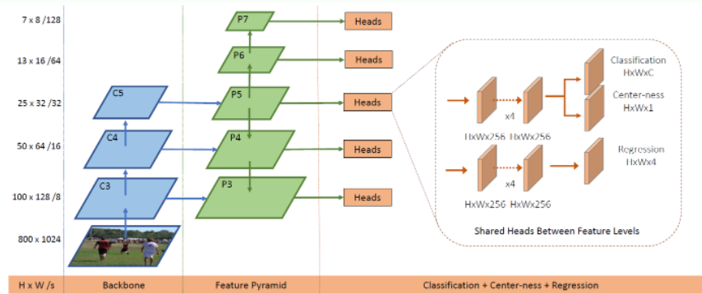

*Fig 2.FCOS: Network Architecture*

**Inputs, Notations, and Outputs**

* Let Fi (Size of HWC) represent the characteristic mappings at coat I of a foundation CNN, and s represent the entire stride till the coat.
* The foundation-accuracy surrounding container for an insert picture are described as Ji, where Ji=(x(i)0, y(i)0, x(i)1, y(i)1, c(i)) where x(i)0, y(i)0, x(i)1, y(i)1 are the coordinates of the surrounding container's left-top and right-bottom area. The object class is denoted by c(i).
* C represents the total number of classes. C=80 in MS COCO, for example.
* Position (x, y) is regarded a optismistic test if it falls inside any foundation-accuracy box and the location's division stage c* is the class label of the ground-truth box. Apart from that, the sample is bleak and c*=0 (surround).
* As indicated in the first picture at the top of the narrative, the regression goals for the location are a 4D real distance t*=( t*,b*,l*,r*). The distances from the position to the four corners of the enclosing box are given by b*, t*, r*, and l*.
* If the plot (x, y) is connected with a vault container Ji, the instruction regression objectives for the plot may be written as (Eq. (1)):

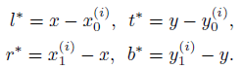

* Our networks' last layer forecasts an 80D vector p of classification points and a 4D distance t = ( t, l, r, b) vault container coordinates.
* The C binary classifiers have been trained.
* For classification and regression branches, four convolutional coat are inserted after the feature plots of the backbone networks.
* Because the regression objectives are always productive, exp(x) is used to transfer any real numeral to the top of the regression split(0,).

1. EXPERIMENTAL RESULTS

Introducing a fully convolutional single-stage article revealer (FCOS) to grasp article revealer , as well as pixel-by-pixel predictive semantic segmentation. Almost all modern article revealers such as YOLOv3,RetinaNet, SSD.

Swift RCNN depends on predefined reporter containers. In difference, the suggested revealer FCOS has neither an reporter container nor a suggestion. FCOS completely eliminates the costly calculations associated with anchor boxes, such as the calculation of overlap during training, by removing the standard set of anchor containers. More importantly, it avoids the anchor container hyperparameters that are very sensitive to the final recognition performance.

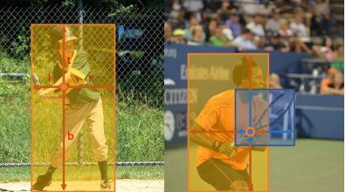

Fig 3.– *As seen in the left picture, FCOS predicts a 4D direction representing the position of a hurdle article at each forepart constituent. The right figure demonstrates that when a place is located in numerous hurdle articles, it might be difficult to determine which hurdle article this position should lapse to.*

We offered an outline of learnable picture modification using a secret key and its applications in this work.

Although encrypted pictures have a variety of qualities, we concentrated on two: compressibility and learnability. These qualities enable us to not only compress encrypted pictures but also apply them to machine learning methods. Furthermore,utilizing an image modification mechanism, unique characteristics controlled by a key may be inserted in pictures, resulting in adversarially resilient defenses and model protection.

However, traditional transformation methods continue to have a number of flaws. In general, picture encryption solutions must be resistant to a variety of assaults. Furthermore, when using encrypted pictures in privacy-preserving machine learning, classification performance should be maintained from an application standpoint.

The advantage of this algorithm is that it is fast and economical, yet it is also as accurate as cutting-edge algorithms. It involves improving time efficiency involving both computation and communication time. It also includes getting rid of the massive burden associated with existing approaches.

Observation is now integrated with numerous other FCN-answerable tasks, such as semantic defination, making it simple to reuse concepts from other work.

Observation becomes scheme and reporter liberty, reducing the figure of plan factors dramatically. To obtain good performance, the design parameters often require heuristic adjustment and several methods. As a result, our new observation architecture simplifies the observer, specially its instruction.

Our novel detector eliminates the costly calculations related with reporter container, such as the IOU calculation and similar among reporter container and ground-truth articles during instruction, resulting in quicker training and testing and a lower training memory footprint than its reporter-based cousin.

Here is the Accuracy of the model that we prepared.

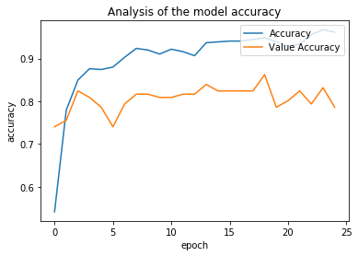

*Fig 4. Analysis of the model accuracy*

We have used two datasets, i.e the images of pothole filled roads and the images of the normal roads.

Below our algorithm distinguishes the images.

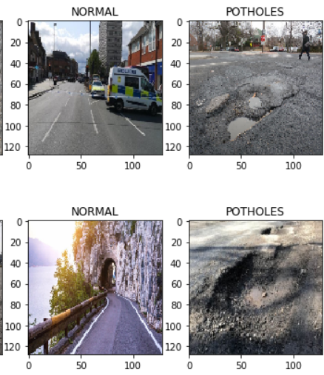

*Fig 5. Identifying the different images*

1. CONCLUSION AND FUTURE WORK

Previous work relied heavily on strong cryptographic primitives to meet the privacy criterion. Deep CNN's complexity unavoidably affected the accuracy and efficiency of its systems.

We first randomly divided the pictures into portions and distributed them to two perimeter servers. We devised a set of safe interlink agreements matching the mismatched levels of CNN using secret-sharing-based secure computing. As a result, we used CNN feature extraction on encrypted data. Furthermore, by relocating information and filtering to the network's perimeter, we could ensure little overhead on cellphone instruments and low web delay.

We showed the security, efficacy, and efficiency of our method through theoretical analysis and actual trials.

Image modification using a secret key is still in its infancy for adversarial defense and model protection. As a result, there are several opportunities for development in terms of classification accuracy and robustness against various threats. Furthermore, while previous research has concentrated on picture classification, additional applications such as object recognition and semantic segmentation should be considered in future studies.

The primary goal of our plan is to safeguard the security of the photos. During the CNN characteristic modification procedure, the perimeter servers or slashers should be prohibited from teaching any material from the pictures or retrieved characteristics. Because cellphone sensors are often resource-constrained, our plan must account for the processing overhead on mobile devices. Meantime, we should drastically minimize the transmission cost among cellphone devices and perimeter servers, resulting in lower response latency.

When sketching a privacy-protected CNN characteristic extraction strategy for cellphone collections, it is hard to meet the three possibilities of security, correctness, and productivity at the same time. To meet privacy requirements, the work so far relies primarily on heavy crypto ancients. Due to the difficulty of the Deep CNN, the correctness and productivity of these strategies have certainly diminished.

This article proposes a new lightweight framework that integrates cellphone sensing and perimeter computing. CNN characteristic modification to protect privacy can be performed at the perimeter of the web. First, arbitrarily break the image into portions and offload each to two perimeter servers. Using secure computations based on secret sharing, we have developed a set of secure interaction protocols for different levels of CNNs. Therefore, we execute CNN characteristic modification for encoded data. In addition, we were able to guarantee mobile overhead and low latency. Build a web by transmitting information and filtering it to the perimeter.

REFERENCES

[1] Z. Xia, X. Wang, L. Zhang, Z. Qin, X. Sun, and K. Ren, “A privacy preserving and copy-deterrence content-based image retrieval scheme in cloud computing,” IEEE Transactions on Information Forensics & Security, vol. 11, no. 11, pp. 2594–2608, 2017.

[2]Yinfu Feng, Mingming Ji, Jun Xiao, Xiaosong Yang, Jian J. Zhang, Yueting Zhuang, and Xuelong Li, “Mining Spatial-Temporal Patterns and Structural Sparsity for Human Motion Data Denoising” in IEEE transactions on cybernetics, vol. 45, no. 12, december 2015.

[3]Jingmin Tu, Jian Yao,Wenjie Zhao, and Binbin Xiang,”Extraction of Street Pole-Like Objects Based on Plane Filtering From Mobile LiDAR Data” in IEEE transactions on geoscience and remote sensing , 2020.

[4]Hanshang Li, Ting Li, Weichao Wang, Member, IEEE, and Yu Wang,”Dynamic Participant Selection for Large-Scale Mobile Crowd Sensing” in IEEE Transactions on Mobile Computing ,2018.

[5] Kai Huang, Ximeng Liu, Shaojing Fu,, Deke Guo and Ming Xu, “A Lightweight Privacy-Preserving CNN Feature Extraction Framework for Mobile Sensing ,” in Proceedings of the IEEE conference on Transactions of Dependable Computing 2018.

[6]A. Sharif Razavian, H. Azizpour, J. Sullivan, and S. Carlsson, “Cnn features off-the-shelf: an astounding baseline for recognition,” in Proceedings of the IEEE conference on computer vision and pattern recognition workshops, 2014, pp. 806–813.

[7] J. Johnson, A. Karpathy, and L. Fei-Fei, “Densecap: Fully convolutional localization networks for dense captioning,” in Proceedings of the IEEE Conference on Computer Vision and Pattern Recognition, 2016, pp. 4565–4574.

[8] Wei Tu , Yatao Zhang, Qingquan Li, Ke Mai, and Jinzhou Cao, “Scale Effect on Fusing Remote Sensing and Human Sensing to Portray Urban Functions” in IEEE geoscience and remote sensing letters, 2020.

[9] Karel Lenc and Andrea Vedaldi, “Understanding Image Representations by Measuring Their Equivariance and Equivalence” International Journal of Computer Vision

<https://doi.org/10.1007/s11263-018-1098-y>, April, 2018.

[10] Dr. Anna Saro Vijendran and S.Thavamani, “Survey of Caching and Replica Placement Algorithm for Content Distribution in Peer to Peer Overlay Networks” in [ACM Press the Second International Conference - Coimbatore UNK, India (2012.10.26-2012.10.28)] .

[11] Sasank Reddy, Deborah Estrin, and Mani Srivastava, “Recruitment Framework for Participatory Sensing Data Collections”in Pervasive Computing Volume 6030 || Recruitment Framework for Participatory Sensing Data Collections. , 10.1007/978-3-642-12654-3(Chapter 9), 138–155.

[12] Michał Piórkowski, Natasa Sarafijanovic-Djukic and Matthias Grossglauser in their “A Parsimonious Model of Mobile Partitioned Networks with Clustering''in IEEE 2009 First International Communication Systems and Networks and Workshops (COMSNETS) - Bangalore, India (2009.01.5-2009.01.10)] 2009 First International Communication Systems and Networks and Workshops - A parsimonious model of mobile partitioned networks with clustering.()1–10.

[13] Toshinori Araki, Jun Furukawa, Yehuda Lindell, Ariel Nof, Kazuma O'hara, “High-Throughput Semi-Honest Secure Three-Party Computation with an Honest Majority”, in ACM Press the 2016 ACM SIGSAC Conference - Vienna, Austria (2016.10.24-2016.10.28)] Proceedings of the 2016 ACM SIGSAC Conference on Computer and Communications Security - CCS'16 - High-Throughput Semi-Honest Secure Three-Party Computation with an Honest Majority (), 805–817.

[14] Ali Sharif Razavian Hossein Azizpour Josephine Sullivan Stefan Carlsson, “CNN Features off-the-shelf: an Astounding Baseline for Recognition”, 2014 IEEE Conference on Computer Vision and Pattern Recognition Workshops.